H.T No
Regulations:
A17

Sreenidhi Institute of Science and Technology
(An Autonomous Institution)
Code No: 6C511 Date: 20-Mar-2021(FN)

B.Tech III-Year I- Semester External Examination, March/April - 2021 (Supplementary)
DIGITAL COMMUNICATIONS (ECE)

Time: 3 Hours Max.Marks:75

Note: a) No additional answer sheets will be provided.
b) All sub-parts of a question must be answered at one place only, otherwise it will not be valued.
c) Missing data can be assumed suitably.

ANSWER ANY 5 OUT OF 8 QUESTIONS. EACH QUESTION CARRIES 15 MARKS.

Bloom's Cognitive Levels of Learning (BCLL)
Remember | L1 | Apply | L3 | Evaluate | L5
Understand | L2 | Analyze | L4 | Create | L6

 |  |  | BCLL | CO(s) | Marks
1. | a) | With a neat sketch explain the basic elements of a digital communication system. | L2 | CO1 | [8M]
 | b) | Compare the performance of PCM and DM systems in terms of overall signal quality and equipment complexity. | L5 | CO1 | [7M]
2. | a) | Explain the power spectra of digital PAM signals. | L2 | CO2 | [8M]
 | b) | Write a brief note on Matched Filtering. | L2 | CO2 | [7M]
3. | a) | The bit stream d(t) is to be transmitted using DPSK. If d(t) is 001010011010, determine b(t). Show that b(t) b(t-T_{b}) yields the original data. | L6 | CO3 | [8M]
 | b) | Derive the probability of error of QPSK. | L5 | CO3 | [7M]
4. | a) | One of five possible messages Q₁ to Q₅ having probabilities 1/2, 1/4, 1/8, 1/16, 1/16, respectively, is transmitted. Calculate the average information. | L5 | CO4 | [8M]
 | b) | Explain about Bandwidth-S/N trade off. | L4 | CO4 | [7M]
5. |  | Draw the state diagram, tree diagram, and trellis diagram for k=3, rate 1/3 code generated by g₁ (x) = 1+x² , g₂(x) = 1+x and g₃ (x) = 1+x+x² . | L5 | CO5 | [15M]
6. | a) | Briefly explain about CDMA. | L2 | CO6 | [8M]
 | b) | Discuss in detail about PN sequence generation. | L2 | CO6 | [7M]
7. | a) | Explain about quantization in PCM. | L2 | CO1 | [5M]
 | b) | Write a brief note on Eye diagram. | L2 | CO2 | [5M]
 | c) | Explain the generation of DPSK signals. | L2 | CO3 | [5M]
8. | a) | Calculate the capacity of the discrete channel shown in Fig.1. Assume r_{s} =1 symbol/sec.  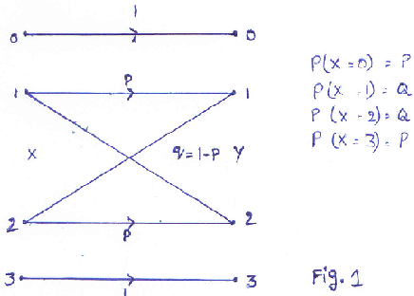 | L5 | CO4 | [5M]
 | b) | Write a brief note on Syndrome calculation. | L3 | CO5 | [5M]
 | c) | Discuss the concept of spread spectrum. | L2 | CO6 | [5M]

-- 00 -- 00 –

